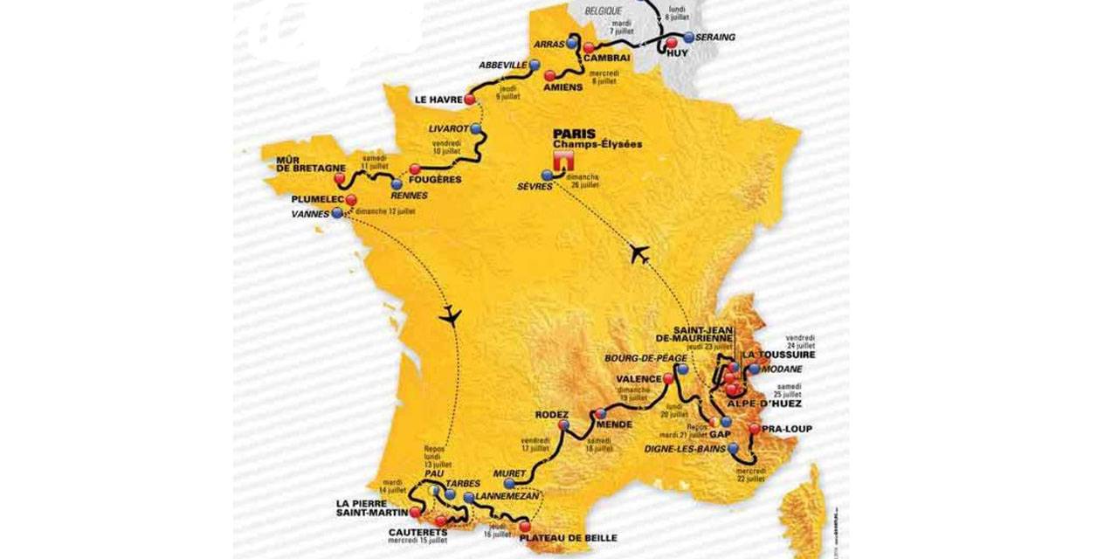

The Tour de France

Challenge

at

Off Road

The TdF unlimited pass goes on sale MONDAY!

Pricing = 65$ (by June 27)

80$ (by July 3)

95$ (after July 3)

**3rd Annual TDF Challenge at Off Road!**

**July 4-26th**

***ALL*** cycling classes count towards the grand prizes!

***Plus*** daily raffle prizes from our sponsors.

All you have to do is show up to ride and YOU could WIN prizes from any one of these amazing places:

@offroaddc| #OffRoadTDF2015